PYTHON BASIC PROGRAM
1)Calculate average of 5 numbers.
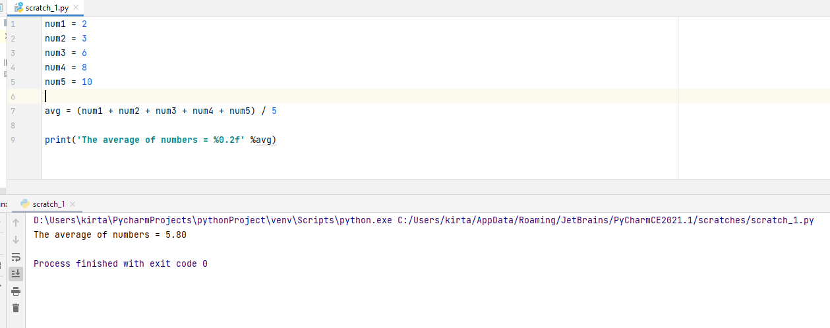
2) Check whether number is even or odd.
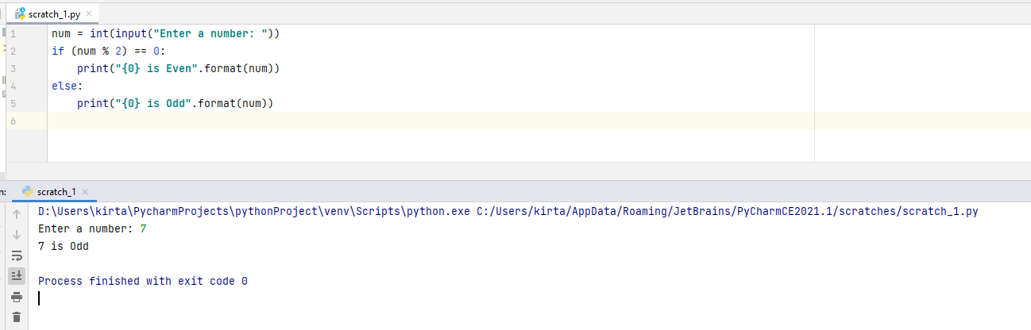
3) Take a year and check whether it is leap year or not
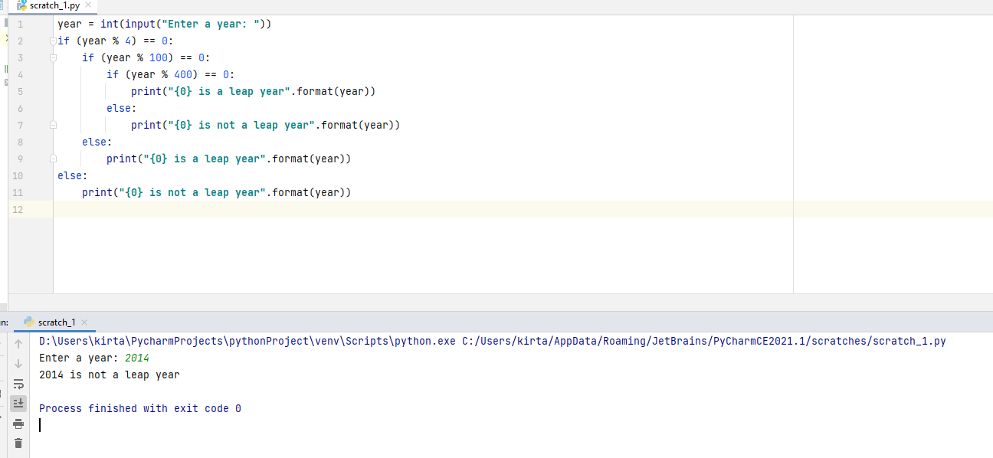
4) Take a number and check whether it is zero, positive or negative.
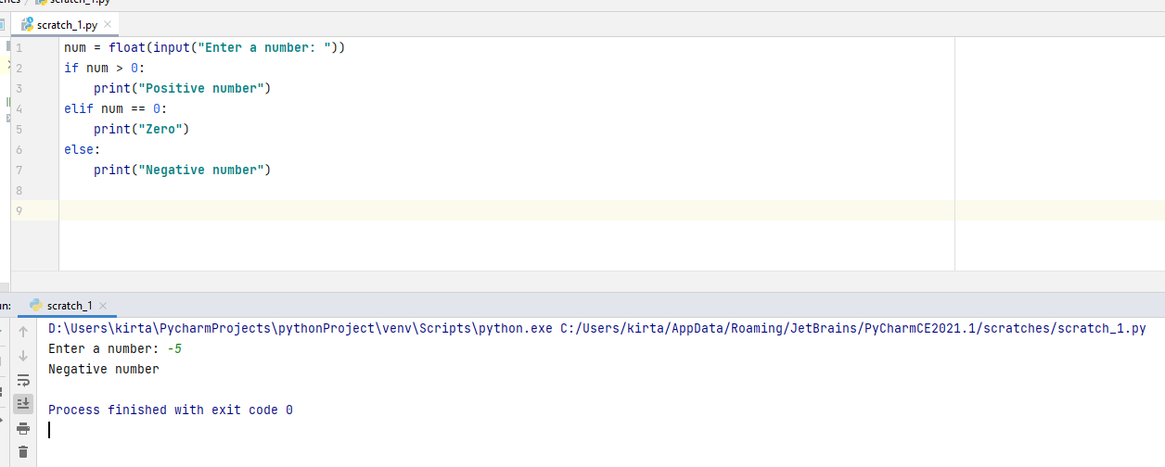
5) Take 2 numbers and display greatest number. (Also check equal number condition)
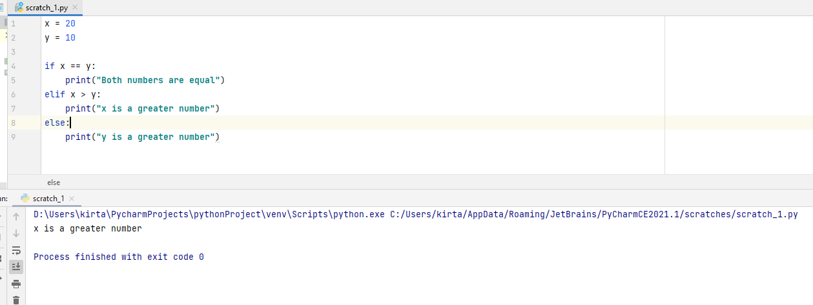
6) Take a number and find factorial of that number.
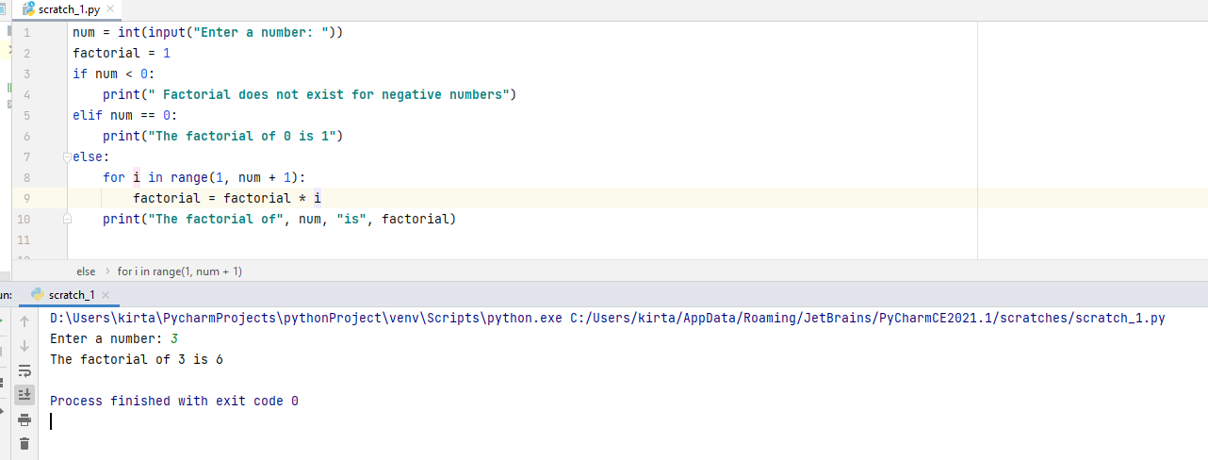

7) Write a program to swap 2 numbers using third variable.
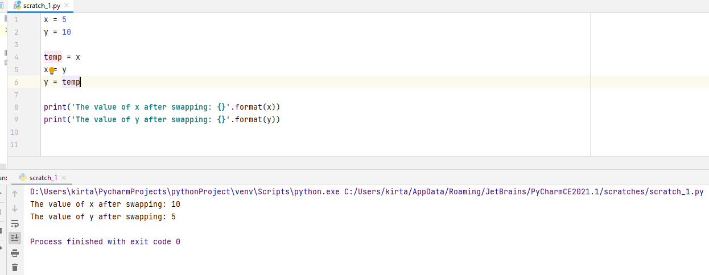
8) Take 2 numbers and find smallest number.
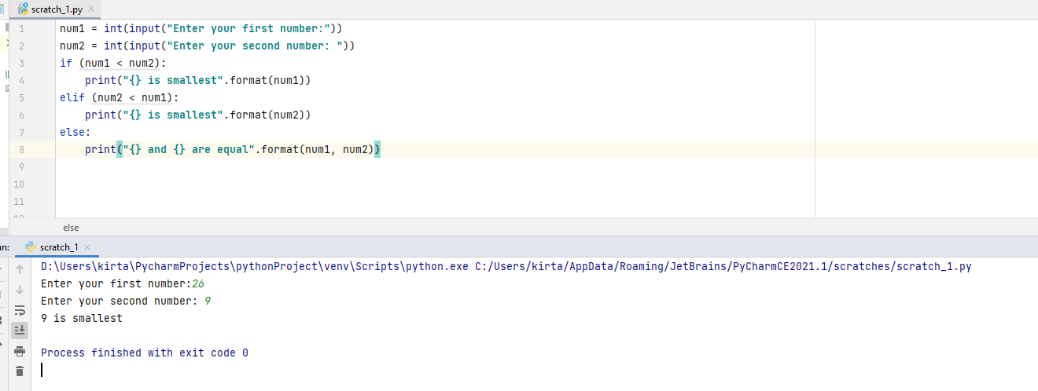
10) Take a number to print the square of a number if it is less than 10.
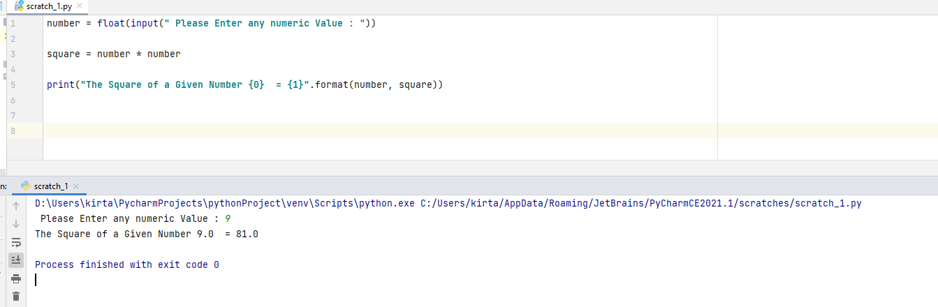

11) Take a number and check whether it is zero, positive or negative using nested IF…ELSE statement .
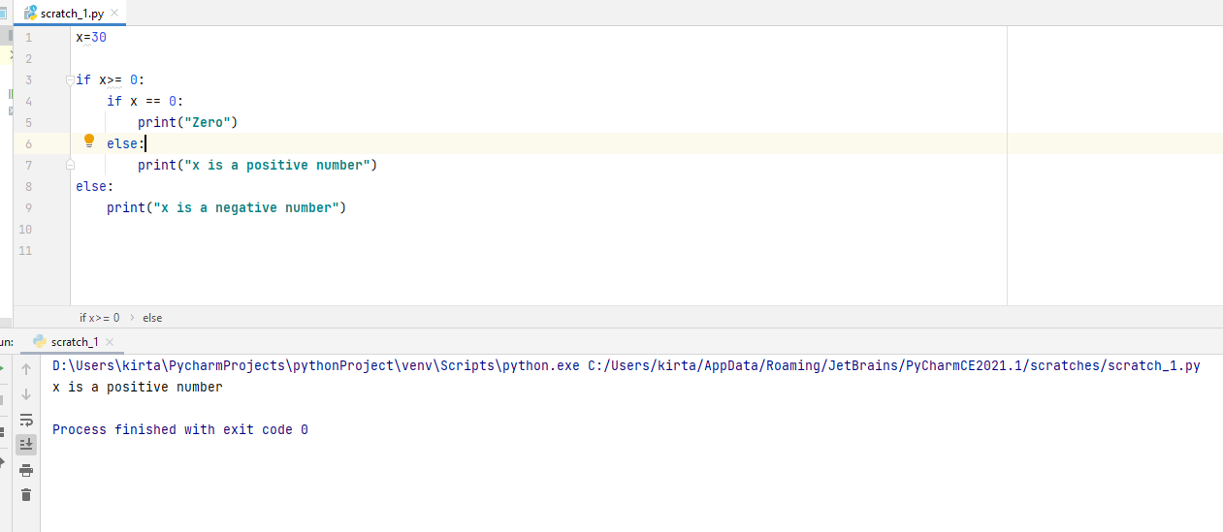

12) Take 3 numbers and find greatest number using nested IF….ELSE statement.
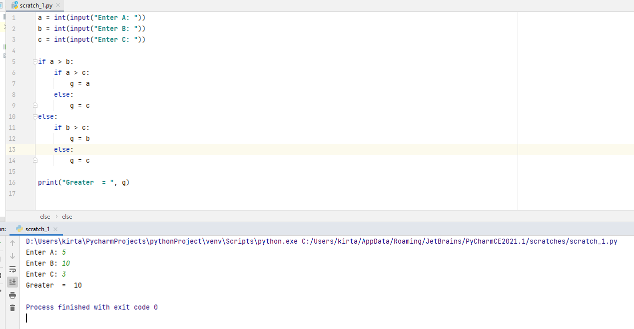

13) Take 3 numbers and find smallest number using logical operator.
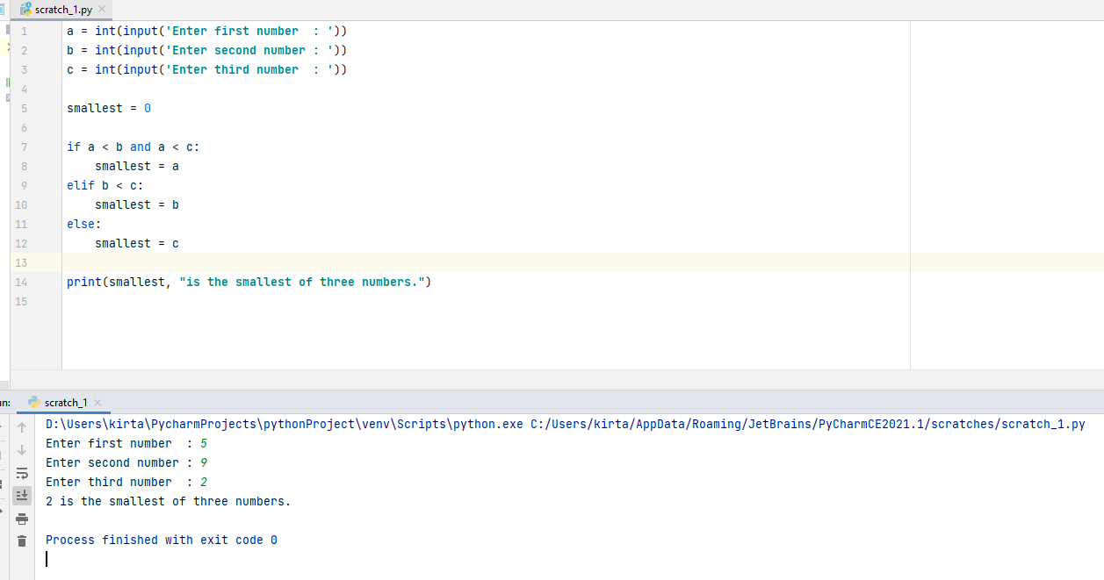

14)Write a program to swap 2 numbers without taking third variable.
